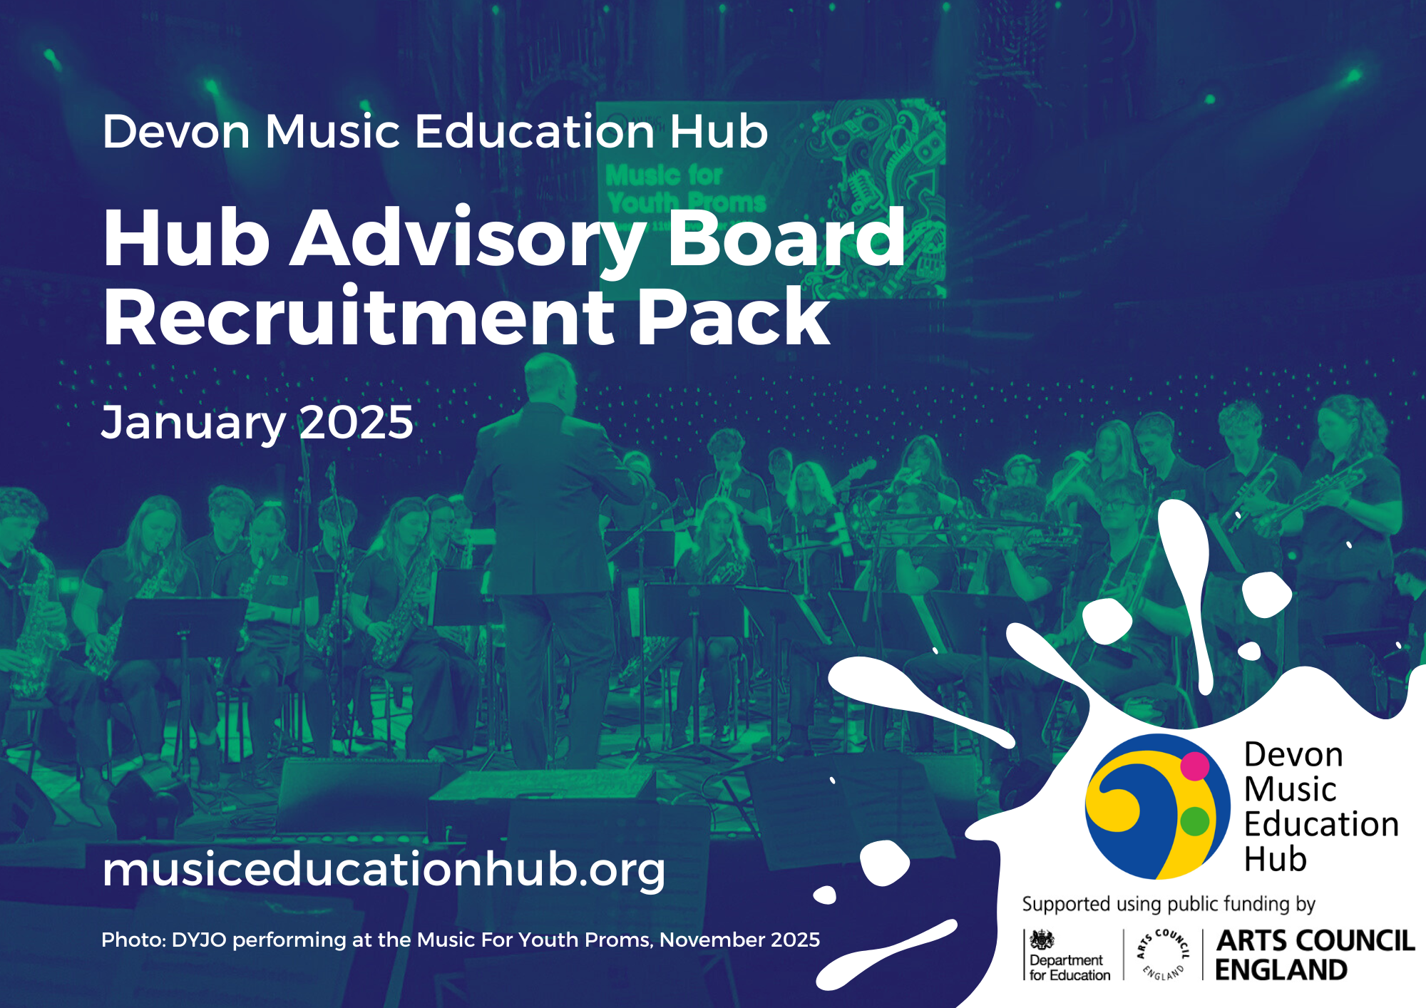
Introduction
Thank you for your interest in joining the Advisory Board of the Devon Music Education Hub, led by Devon County Council, which in September 2024 was confirmed as the Hub Lead Organisation (HLO) for Devon, Plymouth and Torbay.
The Hub receives Department for Education funding through Arts Council England and is responsible for delivering the National Plan for Music Education across the region. Strong, supportive governance is vital, and we are now seeking new Board members to work alongside the Hub Lead, Leadership Team, and wider colleagues to oversee and guide the Hub’s work.
We are looking for exceptional individuals who can contribute valuable experience and complementary skills to our governance. You may find it helpful to read our 2024-25 Annual Review before applying.
Thank you again for your interest in the Advisory Board. We look forward to receiving your application
Richard Jones
Independent Chair
What are Music Hubs and Hub Lead Organisations?
Music Hubs are partnerships, led by a Hub Lead Organisation (HLO), that support and deliver high-quality music education for children and young people within a local area. There are 43 Music Hubs across England, each working to fulfil the aims of the government’s National Plan for Music Education. HLOs receive two ring-fenced grants to deliver this work:
- Revenue grant: core funding to coordinate and support music education across the Hub partnership in line with the NPME.
- Capital grant: funding to increase the availability and accessibility of musical instruments, equipment, and technology.
National Plan for Music Education
The Power of Music to Change Lives – A National Plan for Music Education (NPME) sets out the government’s vision for all children and young people to learn to sing, play an instrument, create music together, and progress their musical interests—including towards professional pathways. It highlights the importance of strong partnerships between schools, Music Hubs, music organisations, and the wider music industry to achieve this by 2030.
About You (the Applicant)
We are looking to strengthen our Advisory Board with new members who bring complementary skills, diverse perspectives, and a passion for music education. We value lived experience, inclusive practice, and a broad range of backgrounds, and we particularly welcome applications from individuals who have faced or overcome barriers to musical participation, as well as young people. Following a recent skills audit, we are especially interested in applicants with experience or knowledge in:
  - Early Years, SEND, or alternative provision
  - Higher or further education
  - Diverse musical genres, including non-Western traditions
  - Professional music-making or the music industry
  - Commercial music sector links
  - Marketing or fundraising
  - Risk management and sound financial oversight
  - Impact measurement in arts and culture
  - Understanding of the region and its musical communities
There are no formal qualifications required. However, Board members are expected to:
  - Be committed to supporting young people
  - Uphold high standards of integrity
  - Contribute actively to a high-performing Board
  - Demonstrate sound judgement, creativity, and clear communication
  - Work collaboratively and speak up with confidence when needed
  - Dedicate sufficient time and energy to the role
Minimum Expectations – board members must:
  - Attend quarterly Board meetings (hybrid; first meeting each year in person)
  - Read and contribute to Board papers
  - Attend at least one Hub event per year
  - Support critical activities and bring specialist expertise when needed
  - Champion music education across Devon, Plymouth and Torbay, including within personal networks
  - Support and share the Hub’s social media campaigns

If you have any questions
For a confidential conversation about the opportunity to join the Devon Music Education Hub Board, please contact either:
  - Richard Jones, Independent Board email hubchairing@yahoo.com
  - Lewis Gibbs, Head/Hub Lead email lewis.gibbs@devon.gov.uk

How to apply
We would like to hear about your motivation for applying and how your skills, knowledge and experience meet the requirements of the role of Board member. To apply please complete the following steps – the deadline for applications is 5pm Friday 12 February 2026:

- Please send a current CV by email to Lewis Gibbs, Head/Hub Lead email lewis.gibbs@devon.gov.uk
- Please also complete the online application form

Terms of Reference (last updated September 2025)
Background
Devon Music Education Hub works with schools, music educators and a range of local, regional and national partner organisations to provide an inclusive, diverse and relevant music education offer for all children and young people. As part of a network of Music Education Hubs across England, we are supported using public funding from the DfE and Arts Council England.
Our vision
Devon Music Education Hub believe all children and young people should be able to learn to sing, play an instrument and create music together, and have the opportunity to progress their musical interests and talent, including into a professional creative career.
Our mission
We work with schools, music educators and a range of local, regional, and national partner organisations to provide an inclusive, diverse, and relevant music education offer for all children and young people.
What we do
As part of a network of Music Education Hubs across England, we are supported using public funding from the DfE and Arts Council England. We are tasked with delivering the vision, aims and strategic functions of the National Plan for Music Education.
Our values
Collaboration, Creativity, Efficiency, Equality, Excellence, Inclusion, Knowledge, Resilience.
Our aims
- To ensure every child and young person has equal access to music.
- To help children and young people fulfil their musical potential.
- To support all schools in delivering a broad and balanced curriculum, with music at its heart.

Overview
Devon County Council is the Hub Lead Organisation (HLO) for Devon Music Education Hub, which will cover the upper tier local authority areas of Devon, Plymouth and Torbay from September 2024. The following terms of reference apply to the Devon Music Education Hub Advisory Board.

Effective governance is essential for the success of any organisation. The Hub Advisory Board is not the HLO’s governing body and executive. It is an Advisory Board that plays a vital role both in serving the effectiveness of music education for children and young people across the region and in ensuring that music educators have access to first class training and Continuous Professional Development.

HLO’s are responsible for supporting, delivering and enabling access to high quality music education activity for children and young people within a local area. In Devon, Plymouth and Torbay, the HLO will act as a gateway to create music education provision that works in a local context, both in and out of school. The HLO will help drive the quality of service locally, with scope for improved partnership working, better value for money, local innovation and greater accountability.
Our objective (as a board)
Strong governance provided by support and challenge from a knowledgeable board that represents the views of all stakeholders, particularly young people themselves.
Our values
The group agrees to conduct business using the Public Standards Committee guide – these are:
- Selflessness
Holders of public office should act solely in terms of the public interest. They should not do so in order to gain financial or other benefits for themselves, their family or their friends.
- Integrity
Holders of public office should not place themselves under any financial or other obligation to outside individuals or organisations that might seek to influence them in the performance of their official duties.
- Objectivity
In carrying out public business, including making public appointments, awarding contracts, or recommending individuals for rewards and benefits, holders of public office should make choices on merit.
- Accountability
Holders of public office are accountable for their decisions and actions to the public and must submit themselves to whatever scrutiny is appropriate to their office.

- Openness
Holders of public office should be as open as possible about all the decisions and actions that they take. They should give reasons for their decisions and restrict information only when the wider public interest clearly demands.
- Honesty
Holders of public office have a duty to declare any private interests relating to their public duties and to take steps to resolve any conflicts arising in a way that protects the public interest.
- Leadership
Holders of public office should promote and support these principles by leadership.
Our pledges
- We challenge discrimination by being a positive role model to educate and demonstrate inclusive behaviours in a safe environment.
- We recognise, understand and respect the experiences and abilities of all people enabling an inclusive and supportive environment for all.
- We connect with all communities to support vulnerable and underrepresented groups.
- We foster a sense of belonging amongst members that empowers people of all backgrounds by encouraging them to share their voice and teach others.
Our role
- To monitor the HLO’s delivery of the three aims and five strategic functions the National Plan for Music Education, Local Plan for Music Education (LPME), the Model Music Curriculum and other relevant strategies.
- To provide effective support and challenge of the HLO’s performance, including strategic vision, development, partnerships, delivery, outcomes and use of public funding.
- To approve an annual business plan and all other mandatory documents in accordance with Arts Council England requirements and deadlines, monitoring their implementation thereafter.
- To scrutinise termly reports from the HLO on progress against agreed activity.
- To monitor, advise and comment on the development and use of the HLO’s data and statistics.
- To ensure diversity of provision, equal access to music for all learners and good value for money.
- To monitor the commissioning of music education activity from funded partners and award funding accordingly.
- To ensure that public funding is spent in accordance with Arts Council England’s Terms and Conditions and to be satisfied, through regular financial reports from the HLO, that the budget is balanced at fiscal year-end.

General principles
- Terms of Reference will be reviewed annually.
- There will be four meetings each year.
- Meetings may be held virtually or in-person. When meetings are held in-person, the option to join virtually will be offered whenever possible.
- All meetings will provide both support and challenge regarding the strategic decisions of the HLO, on expenditure, focus areas, needs analysis, Hub performance and evaluation of strategic plans and KPIs.
- All meetings will include opportunities to hear updates from partners and stakeholders (as long as there are no conflicts of interest).
- Board members will receive papers one week in advance of meetings, to ensure objective, evidence-based decisions are made and that there are robust and transparent quality assurance processes in place.
- Meetings will be quorate if there are at least five voting members present.
Membership terms
- A commitment to equality, diversity and inclusion is fundamental to the vision, mission, aims and objectives of HLO. Members must reflect this commitment and the composition of the advisory board should be representative of the community which we serve.
- Members should commit to attend at three of the four meetings annually.
- If a board member is unable to attend, apologies should be sent and/or a deputy from the organisation can attend in their place, with permission from the Chair.
- Should the attendance of a member become a concern (more than two consecutive meetings are missed), the Chair will have a conversation with the member. Should a third consecutive meeting be missed then the member will be deemed to have resigned, and a replacement sought.
- Membership will be for two years and will then be reviewed.
- An independent Chair will be elected and serve for three years with the possibility for extending for a further two years.
- A Vice-Chair will be elected at the first meeting of each year.
- Any conflict of interest should be declared in advance or at the start of each meeting.
- Applications can be made to the HLO for the reimbursement of travel costs for meetings and events where necessary.
Board representation & current membership
- An Independent Chair – Richard Jones
- Hub Lead – Lewis Gibbs
- One appropriately senior representative (Team/Senior Leader) of Devon Education Services – Vacant.
- One appropriately senior representative (Team/Senior Leader) of Plymouth City Council – Jozzy Mudzingwa.
- Elected members representing Devon County Council and Plymouth City Council – Cllr Andrew Leadbetter & Cllr Sally Cresswell.
- Three representatives from the wider music education/cultural sector – Dame Janet Ritterman, Liz Hill, vacant.
- Representatives from schools and school governors – Tim Baker, David Perkins, Ian Rogers, Pete Twyman, Heidi Price, and Stu Penman.
- Additional representatives of strategic partner organisations – Vacant.
Other stakeholders
- We will work with stakeholders to establish a shadow ‘Youth Board’ with the aim of ensuring the views of children and young people are reflected in decision-making.
- Funded partner organisations participate in regular ‘Hub Partner Network Meetings’ to discuss burning issues and provide feedback and suggestions.
Meeting Dates
Meeting dates should be set an Academic Year in advance.
Dissolution
The group will dissolve if:
• Devon County Council ceases to be the HLO for Devon, Plymouth and Torbay.
• The structure and/or funding of Music Hubs changes substantially.
• The DfE or Arts Council England deems that such Boards are no longer required.

This policy was last reviewed September 2025

