Schools Music Education Plan (SMEP): Self-evaluation tool for schools
This document contains guidance for schools from Devon & Torbay Music Education Hubs on:
Writing a School Music Policy
Using the Schools Music Education Plan (SMEP) self-evaluation tool for schools
Applying for Music Education Grant (MEG) funding

Writing a School Music Policy
Devon & Torbay Music Education Hubs recommend writing a School Music Policy (which outlines how music is delivered in your school; how music relates to your school’s values; and how it is structured and delivered), as a useful document for a range of audiences, including Ofsted, Governors, and parents. It should not be long and should be reviewed every two years (or earlier as appropriate). By using the prompts below, schools can achieve an overview of the current delivery of music education, resulting in an effective School Music Policy. Further guidance can be offered by the Music Development Lead for your area.

Primary (age 5-11) | Secondary and post-16 (age 11-18)
This document should include:  - Who teaches curriculum music lessons?  - How is music timetabled weekly?  - How is musical progression assessed?  - What provision is there for singing? Is there a regular whole school (or phase) singing opportunity? Is there a school choir? Is there a regular accessible music opportunity (in relation to SEND)?  - What instrumental tuition and/or extra-curricular instrumental ensemble opportunities are available? What are these opportunities and when do they take place?  - Which external music organisations regularly work in the school? Who are the organisations and what is their remit?  - Who is the assigned Music Coordinator/Subject Lead?  - How does the school link with Devon & Torbay Music Education Hubs and hub partner organisations?  - How often are there music performances?  - How is music used in cross-curricular work?  - How inclusive is music provision in the school? How do you ensure all children are catered for?  - How is technology used to enhance musical learning? | This document should include:  - How is music delivered across KS3?  - How does KS3 provision build upon prior attainment at KS2?  - Who is the assigned lead for music in the school?  - What provision is offered beyond KS3 (e.g. GCSE, RSL Awards, BTEC, A level)? What courses are offered and with which exam board? How many students are currently taking these courses in each year group?  - How is musical progression assessed?  - What staffing is in place for curriculum music and what is each individual’s role?  - What provision is there for singing?  - What instrumental tuition and/or extra-curricular instrumental ensemble opportunities are available? What are these opportunities and when do they take place?  - Which external music organisations regularly work in the school? Who are the organisations and what is their remit?  - How does the school link with Devon & Torbay Music Education Hubs and hub partner organisations?  - How often are there music performances?  - How is music used in cross-curricular work?  - How inclusive is music provision in the school? How do you ensure all children are catered for?  - How is technology used to enhance musical learning?

Using the Schools Music Education Plan (SMEP) self-evaluation tool
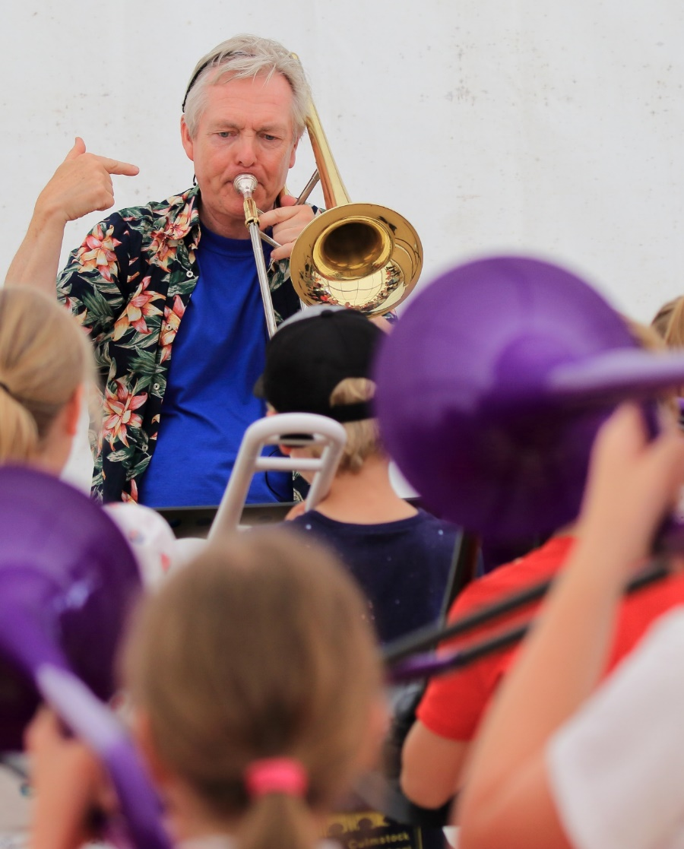
Devon & Torbay Music Education Hubs recommend that schools use the following self-evaluation tool to make a judgement based on their current provision. In order to qualify for Music Education Grant (MEG) funding, schools are expected to share this judgement with the Hub so that we can then offer support to schools as required and according to need.

As a result of the Ofsted report, ‘Music in schools: what hubs must do’ (November 2013), Music Education Hubs in England were tasked with the implementation of Schools Music Education Plan (SMEP). A School Music Education Plan (SMEP) should not be complicated but needs to indicate that schools are delivering the National Curriculum for Music (or other suitable curriculum), and ensuring that pupils have the opportunity to learn to play an instrument, sing regularly, to perform and hear live music, and to work with professional musicians. We also recommend that schools reflect on the recently published Model Music Curriculum. This is non-statutory guidance, which demonstrates one possible approach to the current National Curriculum for Music, giving details of what could be taught in each year to progress logically towards the end of Key Stage 1, 2 and 3 expectations.

In order to support schools, Devon & Torbay Music Education Hubs have produced a simple self-evaluation tool (aimed at Headteachers, Senior Leadership Teams and Music Leaders), which outlines the activities that could be offered as part of a progressive musical programme. While some schools have significant provision for music, others may need more support in further developing their work. We suggest three possible stages of development these stages are similar to Artsmark and are categorised as Bronze, Silver and Gold.

We recommend that schools use this self-evaluation tool to feed into their own School Development Plan and School Music Policy.

Primary
Bronze  (standard expectation for all schools) | Silver  (builds upon bronze) | Gold  (builds upon silver)
- There is an assigned lead person with responsibility for music within the school.  - There is a School Music Policy in place.  - Appropriate measures are taken to ensure that music activities are accessible for all children.  - The National Curriculum for Music (or other suitable curriculum) is delivered on a weekly basis for a minimum of 1 hour, using appropriate schemes of work (or evidence of sustained musical activity on a weekly basis). Where necessary, this can be broken down into smaller units of time.  - Musical progression is assessed.  - There are regular whole school, key stage or phase singing assemblies (or elements of singing within an assembly), which all children can access and engage with.  - External providers occasionally lead projects in the school. | In addition:  - There is an assigned lead person with responsibility for music within the school who engages with Devon & Torbay Music Education Hubs and hub partner organisations.  - Every child is involved in sustained and meaningful musical activities.  - There are regular extra-curricular school choir and instrumental ensemble opportunities available  - There are regular instrumental lessons available, offered through ‘First Access’ Whole Class Ensemble Tuition (WCET) and on an individual or small group basis.  - The school actively engages with music CPD opportunities signposted or directly offered by Devon & Torbay Music Education Hubs and hub partner organisations.  - There are music performance opportunities both in and out of school.  - External providers regularly lead projects in the school that enhance music provision.  - There is an assigned Governor with responsibility for music. | In addition:  - Music is embedded in the whole school (e.g. curriculum or instrumental music lessons can be offered in the morning, not just the afternoon).  - The school is actively engaged in the work of Devon & Torbay Music Education Hubs and hub partner organisations.  - The school engages in and/or leads music CPD opportunities in/out of school and supports other schools.  - There are regular music performance opportunities both in and out of school.  - Projects led by external providers are linked to the curriculum and provision map.  - All musical activities have clear outcomes with tangible evidence of their impact.  - Music making across the whole school is of a high quality with formal monitoring systems in place to support good practice.  - Children are able to communicate about music using appropriate vocabulary in a meaningful way; and/or  - It is evident that music plays an important role in the life and ethos of the school.
All music provision should be progressive and sustainable with a clear focus on the development of skills, knowledge and understanding

Secondary and post-16
Bronze  (standard expectation for all schools) | Silver  (builds upon bronze) | Gold  (builds upon silver)
- There is an assigned lead person with responsibility for music within the school.  - There is a School Music Policy in place.  - Appropriate measures are taken to ensure that music activities are accessible for all pupils.  - The KS3 National Curriculum for Music (or other suitable curriculum) is delivered on a weekly basis for a minimum of 1 hour, building on prior attainment at KS2 using appropriate schemes of work. Where necessary, this can be broken down into smaller units of time.  - Lessons are progressive, challenging, and developmental across a range of genres.  - Music activities are assessed, and the school has accessible assessment and accreditation opportunities for SEND.  - There is at least one regular school choir or instrumental ensemble opportunity, which is run by a member of music department staff.  - External providers occasionally lead projects in the school.  - There is a music provision offer beyond KS3 (e.g. GCSE, RSL Awards or BTEC). | In addition:  - There is an assigned lead person with responsibility for music within the school who engages with Devon & Torbay Music Education Hubs and hub partner organisations.  - Every pupil is involved in sustained and meaningful musical activities.  - There are a range of regular extra-curricular school choir and instrumental ensemble opportunities available.  - There are regular instrumental lessons available, offered on an individual or small group basis.  - The school actively engages with music CPD opportunities signposted or directly offered Devon & Torbay Music Education Hubs and hub partner organisations.  - There are music performance opportunities both in and out of school.  - External providers regularly lead projects in the school that enhance music provision.  - There is an assigned Governor with responsibility for music. | In addition:  - Music is embedded in the whole school (e.g. curriculum or instrumental music lessons can be offered in the morning, not just the afternoon).  - The school is actively engaged in the work of Devon & Torbay Music Education Hubs and hub partner organisations.  - The school engages in and/or leads music CPD opportunities in/out of school and supports other schools.  - There are regular music performance opportunities both in and out of school.  - Projects led by external providers are linked to the curriculum and provision map.  - All musical activities have clear outcomes with tangible evidence of their impact.  - Music making across the whole school is of a high quality with formal monitoring systems in place to support good practice.  - Pupils are able to communicate about music using appropriate vocabulary in a meaningful way; and/or  - It is evident that music plays an important role in the life and ethos of the school.
All music provision should be progressive and sustainable with a clear focus on the development of skills, knowledge and understanding

Applying for Music Education Grant (MEG) funding

To apply for MEG funding, please visit our website https://www.musiceducationhub.org/ and click on funding opportunities on the schools tab. When completing your application, you will be asked to:
- Complete a basic data submission for each school – we have worked very hard to ensure that this is not an onerous process. Precise details are not as important as gaining a good picture of what is happening in local schools, so estimated figures are fine.
- Use our Schools Music Education Plan (SMEP) self-evaluation tool to make a judgement on your current provision (Bronze, Silver, or Gold) and share this with the Hub.
- Tell us how you would like to receive your MEG funding i.e. through your Local Learning Community, cluster, or MAT.

Devon & Torbay Music Education Hubs will provide…
- Music Education Grant (MEG) funding allocation of £400 per school
- 100% subsidised access to award-winning digital resources like Charanga Musical School (primary), Charanga Secondary (secondary), and Focus on Sound Pro (secondary) to support music curriculum delivery.
- 100% subsidised loan of a wide range of class instrument sets to support Whole Class Ensemble Tuition (WCET).
- 100% subsidised membership of Music Mark, the membership organisation and subject association for music.
- Regular email Hubdates with news, resources, events, CPD and funding opportunities.

